Problem:

Write a C++ program to implement a Binary Search Tree with Insertion, Traversal(In-Order, Pre-Order, Post-Order) and Search operation

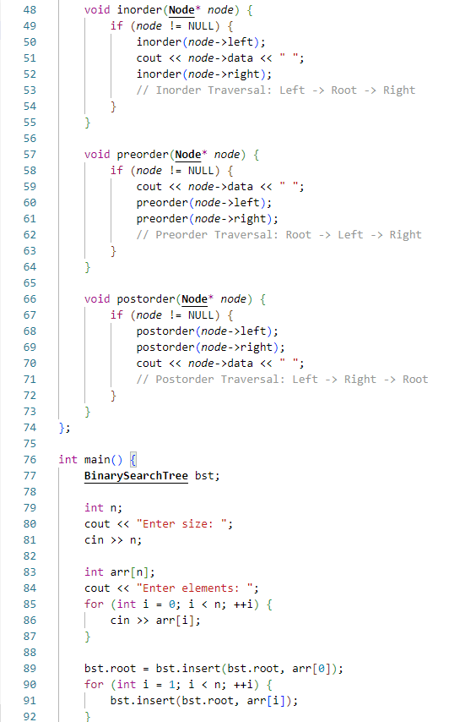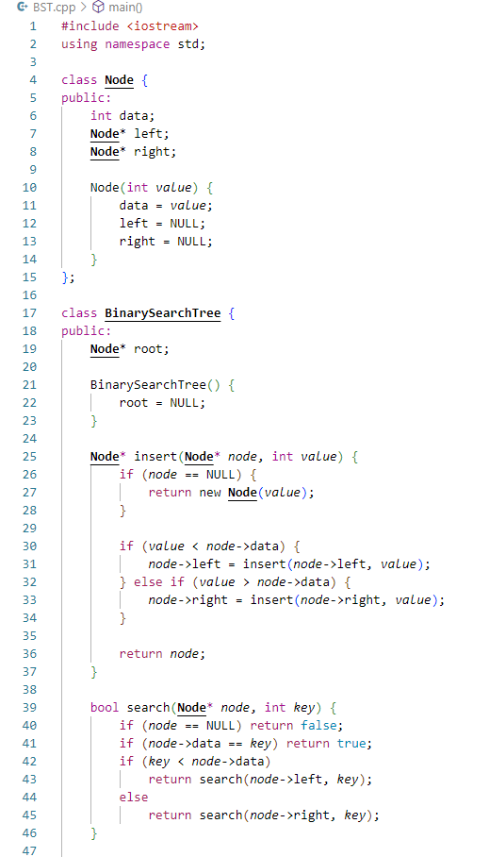Code:

